**What is CAFCR**

The CAFCR is a useful tool and a simple reference model of an architecting method, used to enable the understanding of the inside of a system in relation to its context. The CAFCR model is focused on the relationship between the customer world and the product, and more specific to what determines value and usability of the product. In the framework of this model all the stakeholders and the full life cycle are taken into account.

**CAFCR analysis**

The system of study is approached from 5 different viewpoints: Customer Objectives, Application, Functional, Conceptual and Realization. The *customer objectives* view and the *application* view, capture the needs and provide the **why** for the customer. The needs of the customer (**what** and **how**) provide the justification (**why**) for the specification and the design. The *functional* view describes the **what** of the product, whereas the **how** of the product is described in the *conceptual* and the *realization* view.

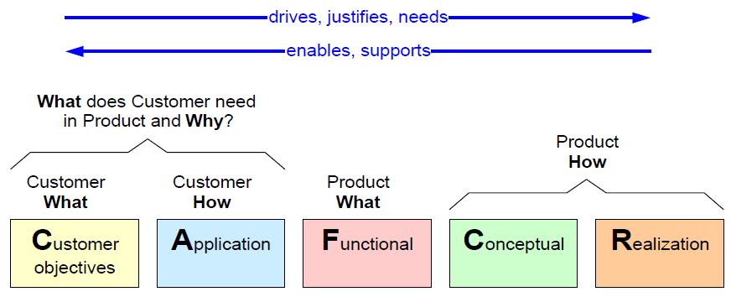  
Figure 1: The five viewpoints for CAFCR model

In order to deliver a product which will satisfy customers’ needs, an iteration over the many different viewpoints is necessary as, it elaborates the thorough analysis of all possible problems that may occur in each stage of product planning.

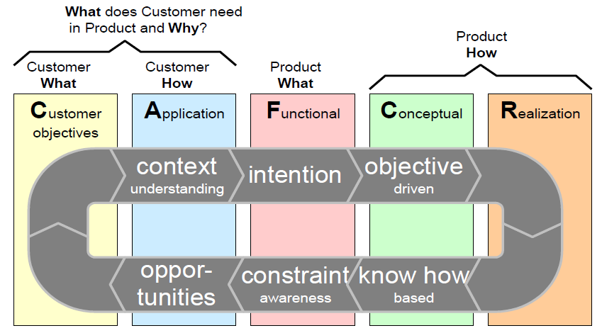  
Figure 2: The CAFCR iterative method

Each of the five viewpoints help to define different characteristics of the designing product and address

**Customer Objectives View**

By this point of view the main goal is to identify customers’ needs (**what**), throughout the whole life cycle of the product, and determine the key drivers. The key drivers identified will be used to derive requirements and make design choices in other views.

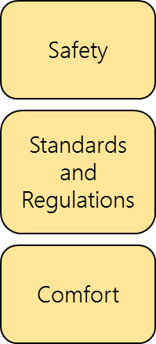

Figure 3: Key-drivers in Customers objectives view

As can be seen in Figure 3, the key-drivers for the development of an Adaptive Cruise Control system in the frame of the 1st and 2nd Module of the PDEng Automotive System Design Program are Safety, Standards and Regulations and Comfort. The safety is the one with highest value, as the developed product will be used in commercial vehicles and the safety of the passengers has the most important value. Closely aligned is comfort, as the product aims at helping and lightening driver’s workload so make travelling a more relaxing experience. The last key-driver identified is the standards and regulations, as NXP was highly interested in providing a document which will summarize the features that an ADAS ACC system should have according to ISO and EURO NCAP standars.

**Application View**

From the Application point of view, the answer to the question **how** is answered. A way to achieve the aforementioned is to identify the main stakeholders and their concerns, throughout the whole life cycle of the product, as well as define the system context. In Figure 4 the stakeholder concerns identified are addressed according to the main needs of the customers, while in Figure 5 the system context is presented. The product delivered to Prof. Dubbelman should be functional, while NXP is mainly caring about delivering a commercial product compliant to ISO and EURO NCAP standards, something about the really want to be informed through this project. From the OEMs point of view, the product developed should be easily maintained and updated so it would be easy adaptable to future changes while comfort and easy in use as well as reliability and robustness are the main concerns for the drivers.

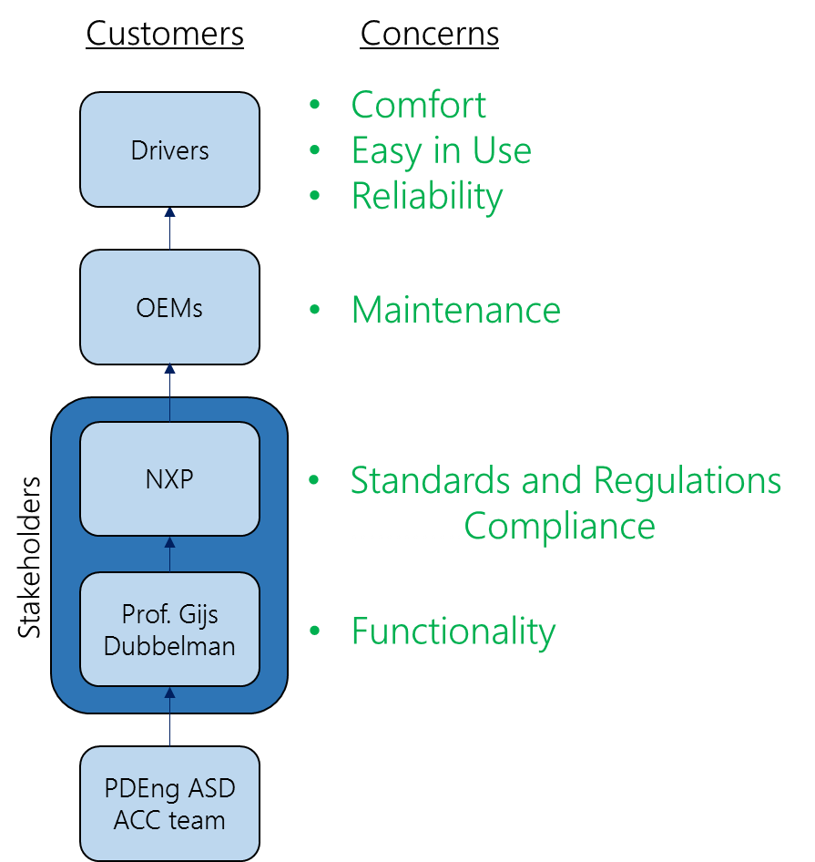

Figure 4: Stakeholders and main concerns

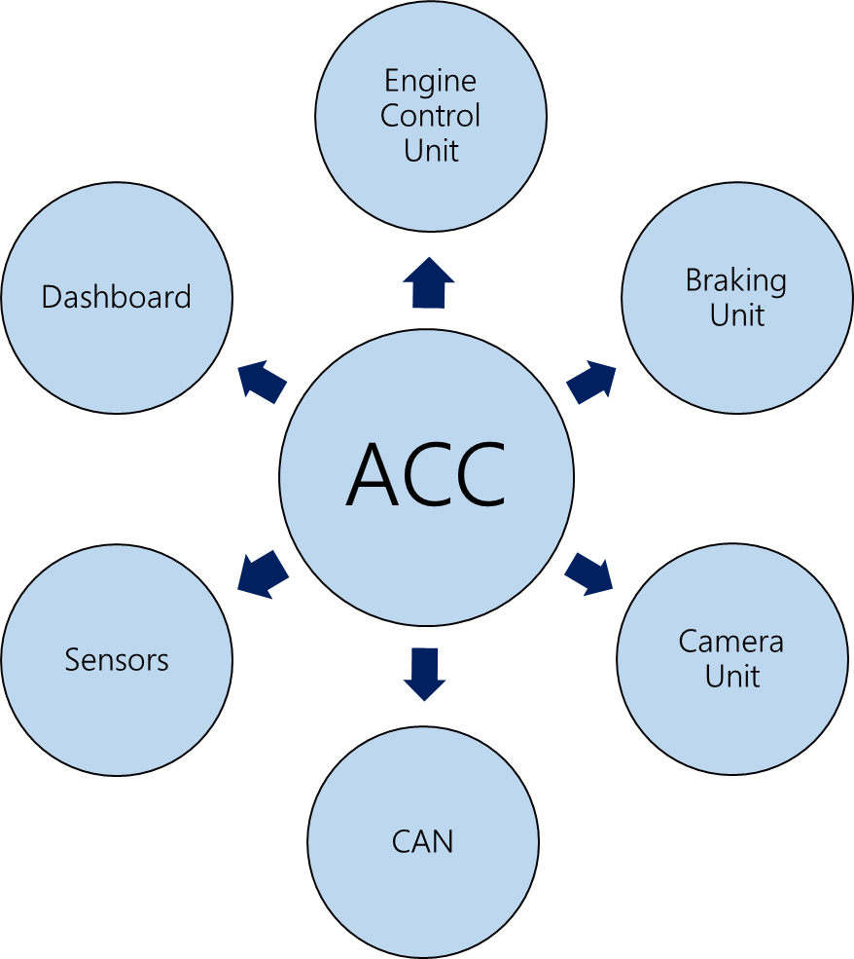

Figure 5: System Context of ACC unit

**Functional View**

From the Functional point of view, the answer to the question **what** is answered. It can be said that, the functionality and performance characteristics are identified and the system of study is considered as a “black box”, while no attention is being paid to the intelligence that is inside. The system should be able to receive data from the driver and the environment (display unit and different kind of sensors, such as speed sensor and image process unit) and after processing those, being able to set the desired vehicle speed and inform the driver with any appropriate signals. The graphic representation of the functional view of CAFCR model is presented in Figure 6.

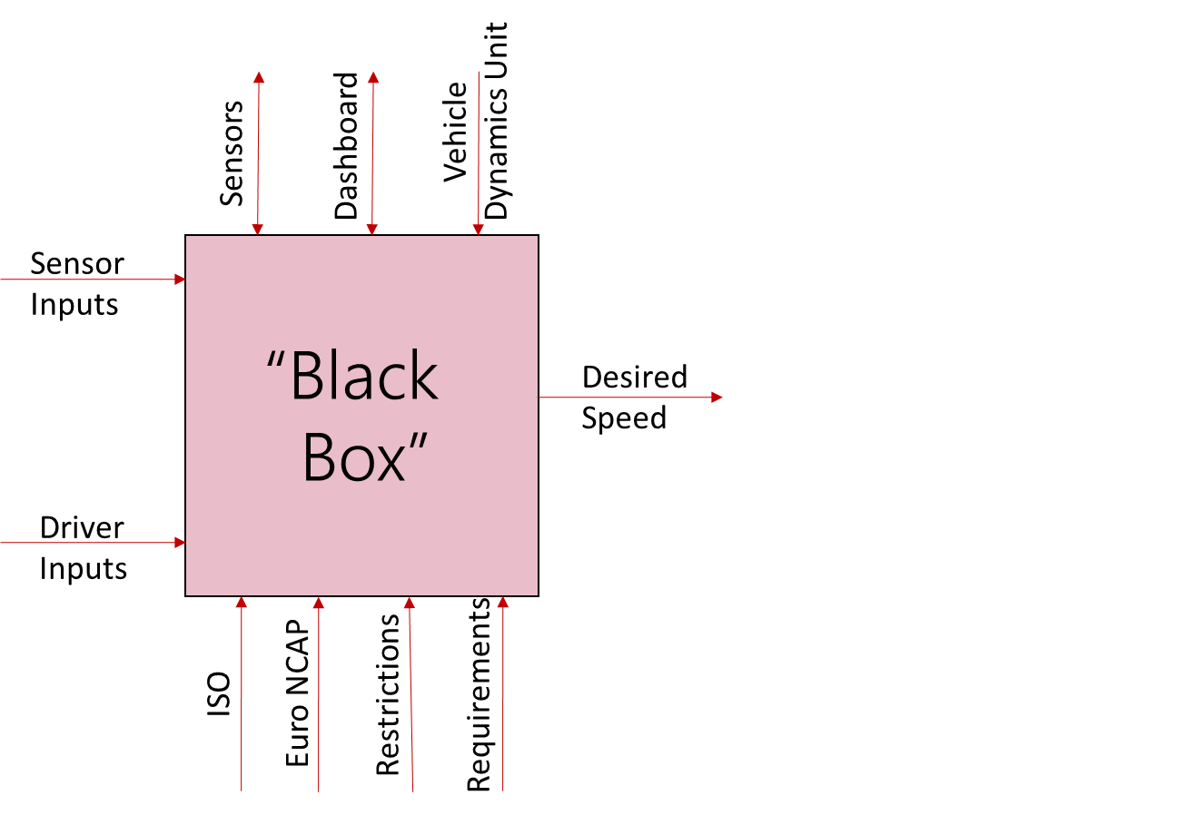

Figure 6: Functional view of the CAFCR model

**Conceptual View**

In the Conceptual point of view, the question **how** the functionality of the system will be achieved, is examined. In other words the **what** is worked out in **how**. At this level, the “black box” is opened and the system is studied in more detail. The analysis at this level can be made either by decomposing the system to its subsystems (construction decomposition) or providing a detail performance model or analyzing in more details the functional model (functional decomposition), which is the method presented in Figure 7, or by a combination of those. Through functional decomposition an insight on how the system will accomplish its job is provided and also end user functions are decomposed into more elementary functions. Keeping in note that the design of complex systems most of the times requires multiple decompositions.

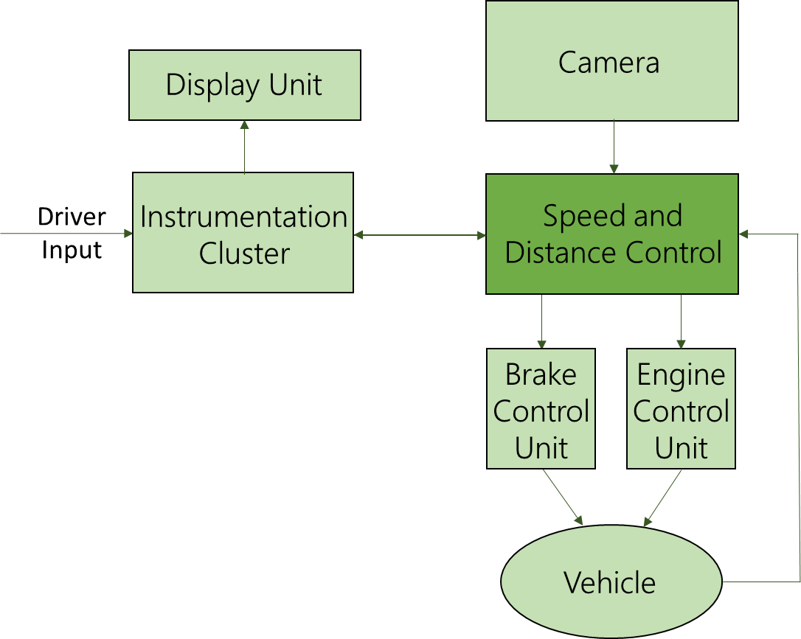

Figure 7: Conceptual View of CAFCR model

The data related to the camera, the driver input and the current state of the vehicle are used from the controller in order to perform the selected ACC function. After processing the data received, the controller should be able to affect vehicle’s speed as well as provide the driver with information.

**Realization View**

From the Realization point of view, the question **how** the functionality of the system will be achieved is examined into more details, as detailed aspects of importance are analyzed. In Figure 8, the High Level Controller receives as inputs all the information regarding the current state of the system and the Camera and is the one responsible in order to choose between the CC and the ACC function of the vehicle and then calculate the desired speed. This output is used as an input from the Low Level Controller, who is responsible for taking all the appropriate actions and adjusting the vehicle speed to the desired level. In Figure 9 the hardware implemented on NXP’s speedgoat is presented.

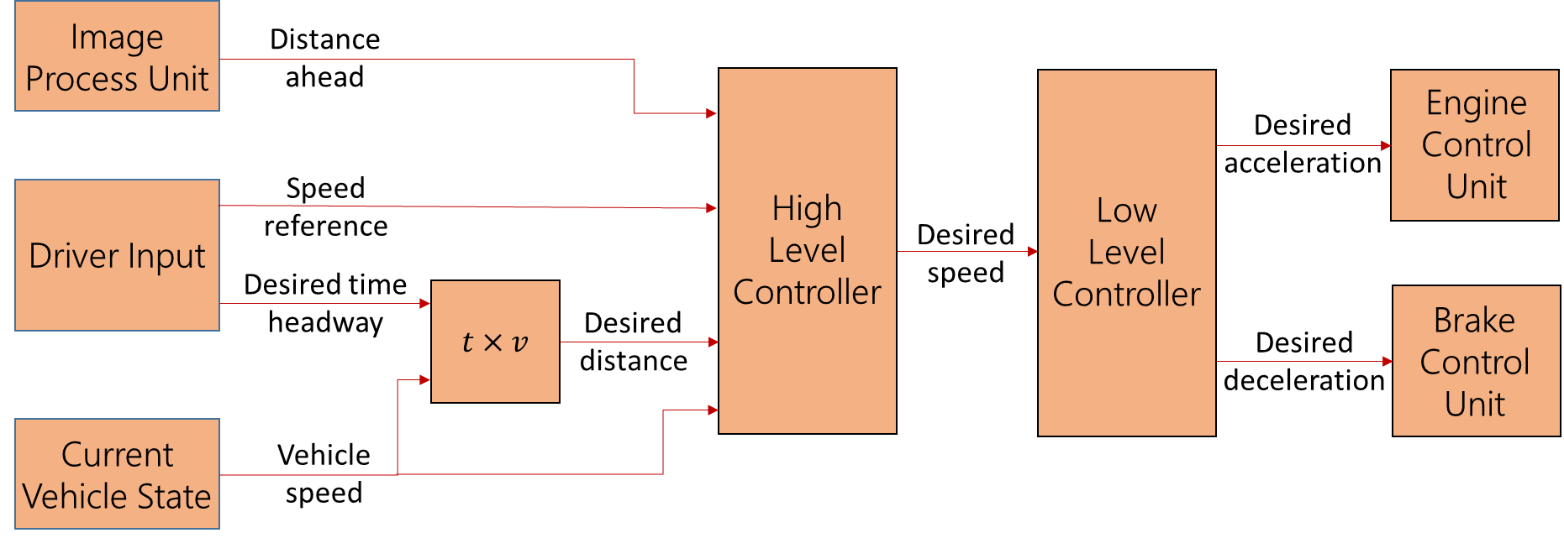

Figure 8: Realization View of CAFCR model

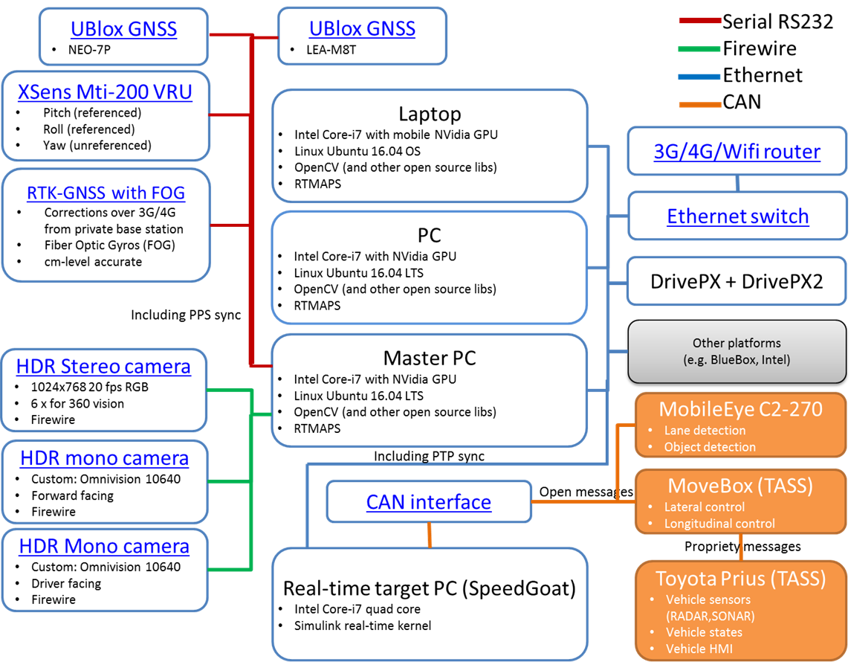

Figure 9: Hardware components implemented on NXP’s speedgoat